Seeds of Love & Hope International Society’s
11th Annual Benefit Gala Basket Stuffers

We are beginning to collect items and/or monies for the much desired baskets for the SOLAHIS Banquet.

- small toddler basket - toys, puzzles, music cd, board books, etc.

- boys & girls baskets – games, stickers, toys, sports equipment, LED flashlights

- men's basket - cards, nuts, tickets to Giants hockey game, driving range tokens, tools, car safety kit, electric tire pump, etc.

- spa basket - soaps, lotions, nail files, gift certificate to manicure or pedicure, facial cleanser, nail polish, head bands, jewelry

- movie night basket – DVD’s, gift certificate for the theatre, popcorn, snacks

- family games night - popcorn and bowls, board game, cards, puzzles, snacks, fun prizes

- bathroom basket - soaps, towels, scrub brush, Kleenex, face clothes, bubble bath etc.

- kitchen/pantry - tea towels, dish clothes, scrubbers, baking items, cookbook kitchen utensils etc.

- food basket - jams, jellies, sauces, cheese, crackers, olives, teas, mugs etc.

- garden basket - garden gloves, spade, trowel, bulbs, seeds, bucket, etc.

- readers basket - book or certificate, hot chocolate with mug, baking, snacks etc.

- culinary basket - crackers, smoked salmon, canned crab or shrimp, pot holders, cutting board/knife, etc.

- much needed are cookies eg: Walkers Shortbread or specialty cookies, candies, chocolates, nuts, bigger candy canes, specialty coffee & teas, Kids treats eg: Smarties, M&Ms, fruit gummies, sours, etc to use as fillers in the baskets.

- containers for making up baskets, eg: baskets, trays, bowls, gift boxes, etc

Basically we can find a place for almost anything you are able give us.

For the very busy ones, gift cards eg: Tim Hortons, Starbucks, Save On Foods, Safeway, gas card, movie tickets, etc, are extremely useful and, cash donations are a great help. We will gladly buy the extras needed to finish off baskets with the donations that we receive.

All items can be brought to Cornerstone Church by November 11th. If you have any questions please contact Edna Hayward, tel: (604) 897-6846 or email: hayward2@shaw.ca

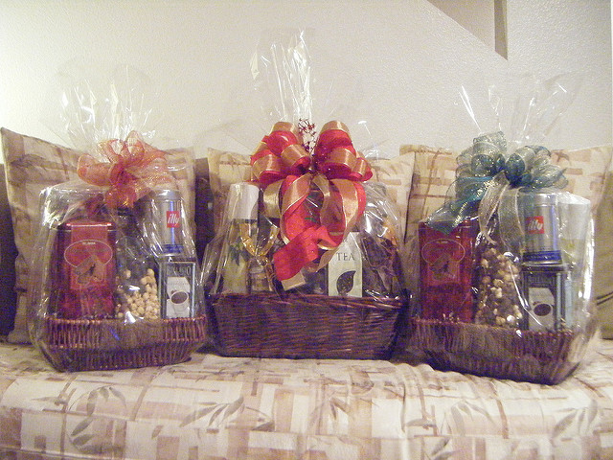

Thank you for your
compassion and care!

